Implement Using Collaboration Diagram
K Vamsi192372062

- Develop a system using UML for Online Shopping System
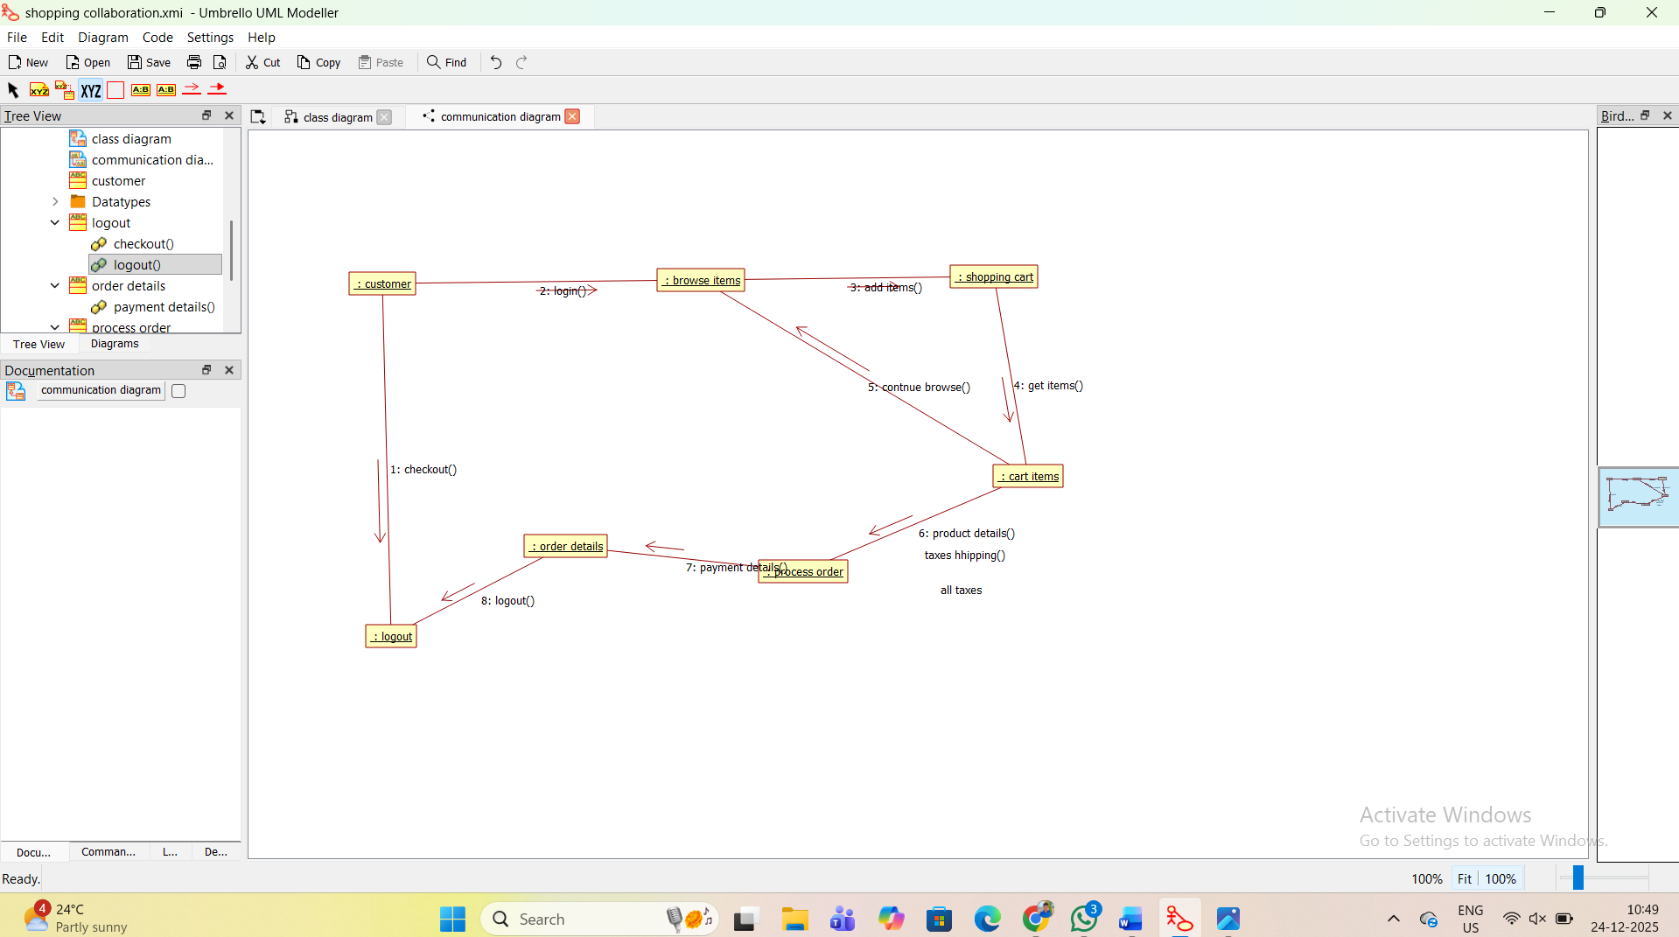

- Develop a system using UML for Online Stock Market System

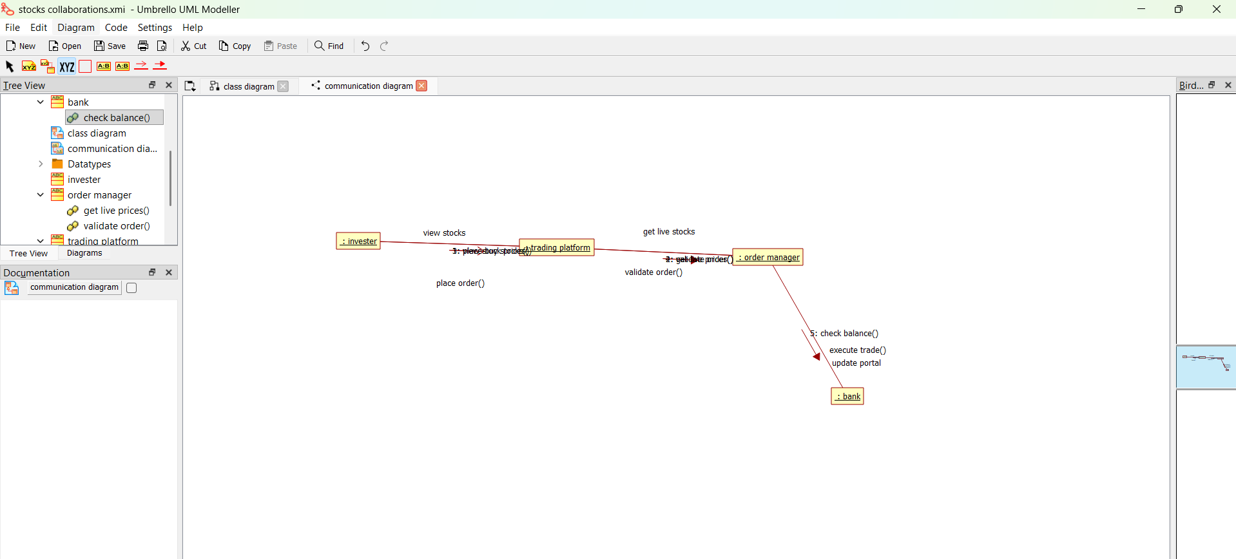
3. Develop a system using UML for Jewellery Shop Management
System
